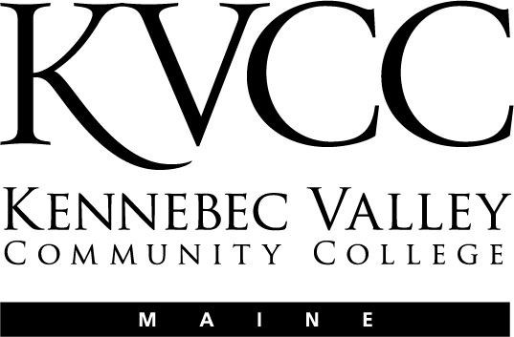
KENNEBEC VALLEY COMMUNITY COLLEGE
FAIRFIELD, MAINE

Social Sciences Department
Approval Date: TBA
Semester: TBA

COURSE NUMBER: | ECE 133 | CREDIT HOURS: | 3
COURSE TITLE: | Language, Literacy and Literature | CLOCK HOURS: | 45
PREREQUISITES: | ECE 131 or ECE 135 or  Permission of Instructor
CO-REQUISITES:

INSTRUCTOR | VOICE MAIL | OFFICE | E-MAIL ADDRESS
TBA | TBA | TBA | TBA
OFFICE HOURS: | TBA

TEXTS:
No Textbook

OTHER MATERIALS:
TBA

COURSE DESCRIPTION:
This course explores children’s language and literacy development. Utilizing State of Maine guidelines, materials, methods and modifications will be developed to implement approaches for language and literacy development. Students will evaluate children’s literature to determine age appropriateness as well as cultural and linguistic competency. Students will define barriers and establish strategies to incorporate language and literacy development in children.
LEARNING OUTCOMES:
Upon successful completion of this course, the student should be able to:

- Describe the significance of language, literacy and literature in early childhood.
- Identify the stages of language and literacy development.
- Identify standards for children’s literature.
- Discuss the barriers to language and literacy development.
- Develop strategies and resources to overcome the barriers of language and literacy development.
- Discuss the importance of early childhood environment and materials needed to enhance language and literacy development.
- Develop, implement, and reflect upon activity plans related to language and literacy.
- Explain the use and importance of technology in language, literacy and literature.
- Demonstrate proficiency in interpersonal communication (ELO).

COURSE CONTENT:
TBA

COURSE ACTIVITIES:

Lesson Plans

The entire course is divided into “Lessons” that cover specific topics and learning objectives in the class. The Lessons are listed in the Course Outline above. Each Lesson introduces you to specific subject matter and asks you to engage in a number of activities. These may include reading, exploring the web, researching, participating in online discussions, quizzes (multiple choice, short answer, and essay questions), and assignments (written work submitted as an attached document in a “drop box”)

Each Lesson consists of:

- A Lesson Plan that outlines the content and provides detailed instructions as to any assignments
- Direct links to any Discussions, Assignments, or Quizzes that go along with that Lesson.

All the Lessons are located in the “Lessons” folder. Click on the Lessons link in the course Menu.

Online Discussions

Online discussions form the backbone of an online class. It is very important for you to participate actively and fully in these discussions. These discussions will be graded and will be available for a specified amount of time (Monday morning until Sunday night on a given week in the course). You are required to participate in these discussions following the instructions that will be provided to you in the online Lessons.

Grading of the online discussions will be done in accordance to this grading rubric:

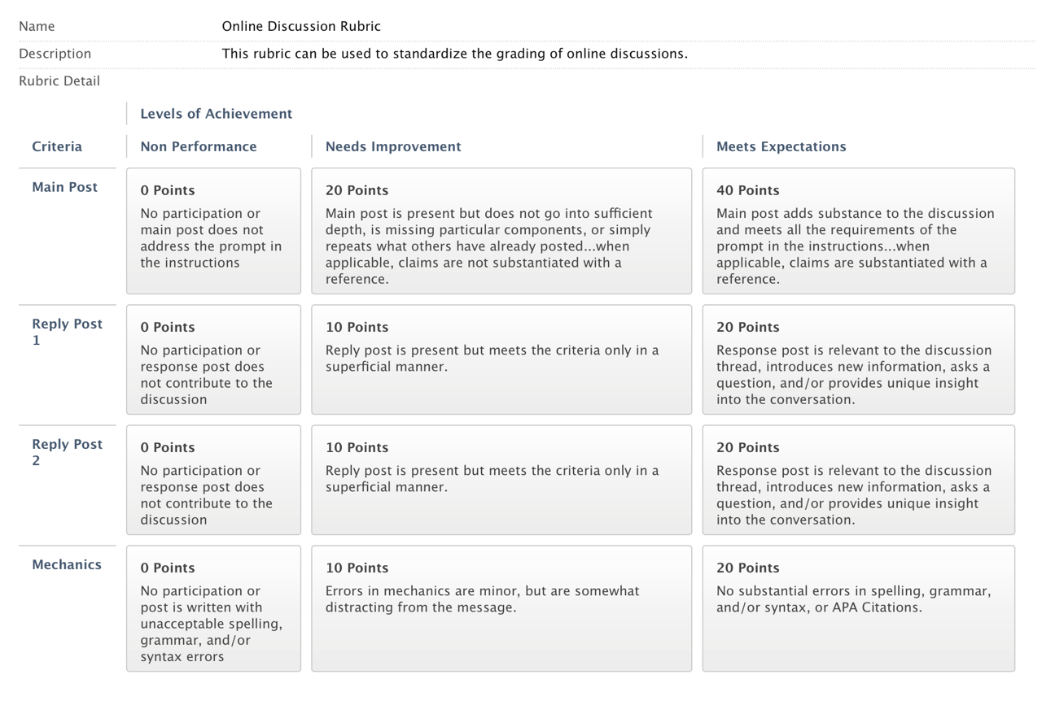

You are, of course, encouraged to post many times through the week. You are also encouraged to post EARLY in the week so that you can benefit from others’ responses to your post and so that others may benefit from your responses).

Please review the online document titled “Course Expectations and Policies”

Lesson Quizzes

These quizzes will consist of questions related to activities I assign in the class, the content of the discussions, or information you gather from research or from your interview (see below).

Within each Lesson outlined you will be provided with a lists of ALL the questions in the specific quiz. You should prepare your answers ahead of time and then enter these answers into the appropriate online quiz.

Quizzes must be completed by the end of the week in which they are assigned. You may be able to work ahead on some of these quizzes as well.

Extensions on the due dates for Quizzes may be allowed with sufficient reason; however, I reserve the judgment to not grant an extension. If you anticipate needing extra time it is best to get in touch with me PRIOR to the due date.

Special Assignments

The following assignments are those that have been incorporated into this class to not only teach you course content, but to also enable you to demonstrate learning associated with the KVCC General Education Outcomes. (See the section on General Education Outcomes at the beginning of this syllabus)

- Interpersonal Communication

It is critical that you review the information I have provided for each of these assignments in the course website. While the assignments are not particularly complicated, they are certainly complex, requiring planning and time management to complete them by their due dates.
GRADING:
Lesson Quizzes and Assignments 20%
Lesson Discussions 30%
GRADING SCALE:

Grade Scale
A 4.00 grade points per credit hour 95-100
A- 3.67 grade points per credit hour 90-94
B+ 3.33 grade points per credit hour 87-89
B 3.00 grade points per credit hour 83-86
B- 2.67 grade points per credit hour 80-82
C+ 2.33 grade points per credit hour 77-79
C 2.00 grade points per credit hour 73-76
C- 1.67 grade points per credit hour 70-72
D+ 1.33 grade points per credit hour 65-69
D 1.00 grade points per credit hour 60-64
F 0.00 grade points per credit hour Below 60
ATTENDANCE POLICY:
TBA

MAKE-UP WORK:

TBA
COURSE REQUIREMENTS:
Click here to enter text.
OTHER INFORMATION:

TBA
In accordance with state and federal law, this College is committed to assisting qualified students with disabilities achieve their educational goals.

If you are in need of an accommodation in this course:
• Students must contact the Dean of Students, Enrollment Services Center, Frye Building, 453-5019,
knormandin@kvcc.me.edu
• Students must provide current, appropriate documentation of their disability.
• Students must make a timely request for accommodation to the Dean of Students.
• Accommodations will not be provided until the faculty member receives a letter requesting accommodations. This letter is created with the Dean of Students and is supported by the documentation of said disability.
• Requests for accommodation must be renewed each semester for each course.

This document is available in enlarged print and on audio tape. Please contact the Dean of Students at 453-5019 or knormandin@kvcc.me.edu

NOTICE OF NON-DISCRIMINATION (2014):

Kennebec Valley Community College does not discriminate on the basis of disability in the admission to, access to, or operation of its programs, services or activities. Students requesting classroom accommodation should be forwarded to the Dean of Students, Enrollment Service Center, Frye Building, phone: 453-5019 or the Director of the Learning Commons, Lunder Library, phone: 453-5084

Complaints about College decisions related to disability accommodations or discrimination must be forwarded to Affirmative Action Officer and ADA Compliance Officer, Dean of Academic Affairs, Enrollment Services Center, 92 Western Avenue, Fairfield, ME 04937, phone: 453-5822.

