
KENNEBEC VALLEY COMMUNITY COLLEGE
FAIRFIELD, MAINE

Social Sciences Department
Approval Date:
Semester: Spring 2015

COURSE NUMBER: | ECE135 | CREDIT HOURS: | 3
COURSE TITLE: | Observing and Recording Children’s Behaviors | CLOCK HOURS: | 45
PREREQUISITES: | None
CO-REQUISITES: | None

INSTRUCTOR | VOICE MAIL | OFFICE | E-MAIL ADDRESS
Enter name | Click here to enter text. | Click here to enter text. | Click here to enter text.
OFFICE HOURS: | Click here to enter text.

TEXTS:
Nilsen, B. Ann. (2017) Week by Week: Plans for Documenting Children’s Development. Wentworth Cengage

OTHER MATERIALS:
Click here to enter text.

COURSE DESCRIPTION:
This course provides a comprehensive overview and hands-on experience using observation, assessment and screening tools in early childhood settings. Students will gain a deeper understanding of disabilities, as well as behavior and discipline in early childhood. The course links curricula, environments, activity plans and child development to observations. Indicators of abuse and neglect are discussed. Students must pass SBI and DHHS background checks to participate in this course.
COURSE OBJECTIVES:
Upon successful completion of this course, the student should be able to:

- Explain the importance and uses of observations.
- Differentiate between subjective and objective as well as formal and informal observation.
- Describe the use of observation tools to inform assessment of child development and identify children with special needs.
- Implement several different observation tools.
- Create effective activity plans based on observations and assessments.
- Develop developmentally appropriate environments and materials based on observation and assessments.
- Explain how to use observation to inform behavior and discipline strategies.
- Explore different types of screening tools and their uses in early childhood.
- Demonstrates proficiency in Quantitative Reasoning (ELO).

COURSE CONTENT:

- TBA

COURSE ACTIVITIES:

Lesson Plans

The entire course is divided into “Lessons” that cover specific topics and learning objectives in the class. The Lessons are listed in the Course Outline above. Each Lesson introduces you to specific subject matter and asks you to engage in a number of activities. These may include reading, exploring the web, researching, participating in online discussions, quizzes (multiple choice, short answer, and essay questions), and assignments (written work submitted as an attached document in a “drop box”)

Each Lesson consists of:

- A Lesson Plan that outlines the content and provides detailed instructions as to any assignments
- Direct links to any Discussions, Assignments, or Quizzes that go along with that Lesson.

All the Lessons are located in the “Lessons” folder. Click on the Lessons link in the course Menu.

Online Discussions

Online discussions form the backbone of an online class. It is very important for you to participate actively and fully in these discussions. These discussions will be graded and will be available for a specified amount of time (Monday morning until Sunday night on a given week in the course). You are required to participate in these discussions following the instructions that will be provided to you in the online Lessons.

Grading of the online discussions will be done in accordance to this grading rubric:

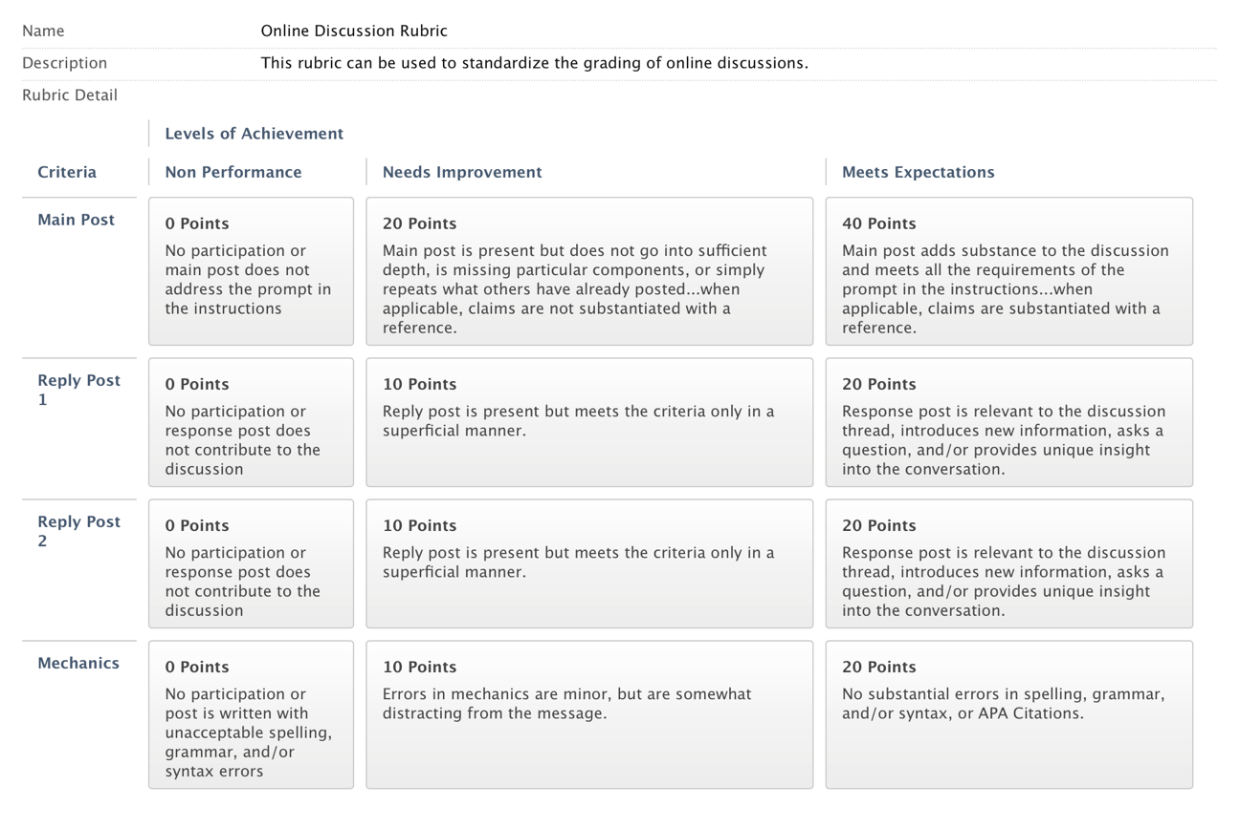

You are, of course, encouraged to post many times through the week. You are also encouraged to post EARLY in the week so that you can benefit from others’ responses to your post and so that others may benefit from your responses).

Please review the online document titled “Course Expectations and Policies”

Lesson Quizzes

These quizzes will consist of questions related to activities I assign in the class, the content of the discussions, or information you gather from research or from your interview (see below).

Within each Lesson outlined you will be provided with a lists of ALL the questions in the specific quiz. You should prepare your answers ahead of time and then enter these answers into the appropriate online quiz.

Quizzes must be completed by the end of the week in which they are assigned. You may be able to work ahead on some of these quizzes as well.

Extensions on the due dates for Quizzes may be allowed with sufficient reason; however, I reserve the judgment to not grant an extension. If you anticipate needing extra time it is best to get in touch with me PRIOR to the due date.

Special Assignments

The following assignments are those that have been incorporated into this class to not only teach you course content, but to also enable you to demonstrate learning associated with the KVCC General Education Outcomes. (See the section on General Education Outcomes at the beginning of this syllabus)

- Quantitative Reasoning

It is critical that you review the information I have provided for each of these assignments in the course website. While the assignments are not particularly complicated, they are certainly complex, requiring planning and time management to complete them by their due dates.
GRADING:
Lesson Quizzes and Assignments 20%
Lesson Discussions 30%
GRADING SCALE:

Grade Scale
A 4.00 grade points per credit hour 95-100
A- 3.67 grade points per credit hour 90-94
B+ 3.33 grade points per credit hour 87-89
B 3.00 grade points per credit hour 83-86
B- 2.67 grade points per credit hour 80-82
C+ 2.33 grade points per credit hour 77-79
C 2.00 grade points per credit hour 73-76
C- 1.67 grade points per credit hour 70-72
D+ 1.33 grade points per credit hour 65-69
D 1.00 grade points per credit hour 60-64
F 0.00 grade points per credit hour Below 60
ATTENDANCE POLICY:
TBA

MAKE-UP WORK:

TBA
COURSE REQUIREMENTS:
Click here to enter text.
OTHER INFORMATION:

TBA
In accordance with state and federal law, this College is committed to assisting qualified students with disabilities achieve their educational goals.

If you are in need of an accommodation in this course:
• Students must contact the Dean of Students, Enrollment Services Center, Frye Building, 453-5019,
knormandin@kvcc.me.edu
• Students must provide current, appropriate documentation of their disability.
• Students must make a timely request for accommodation to the Dean of Students.
• Accommodations will not be provided until the faculty member receives a letter requesting accommodations. This letter is created with the Dean of Students and is supported by the documentation of said disability.
• Requests for accommodation must be renewed each semester for each course.

This document is available in enlarged print and on audio tape. Please contact the Dean of Students at 453-5019 or knormandin@kvcc.me.edu

NOTICE OF NON-DISCRIMINATION (2014):

Kennebec Valley Community College does not discriminate on the basis of disability in the admission to, access to, or operation of its programs, services or activities. Students requesting classroom accommodation should be forwarded to the Dean of Students, Enrollment Service Center, Frye Building, phone: 453-5019 or the Director of the Learning Commons, Lunder Library, phone: 453-5084

Complaints about College decisions related to disability accommodations or discrimination must be forwarded to Affirmative Action Officer and ADA Compliance Officer, Dean of Academic Affairs, Enrollment Services Center, 92 Western Avenue, Fairfield, ME 04937, phone: 453-5822.

