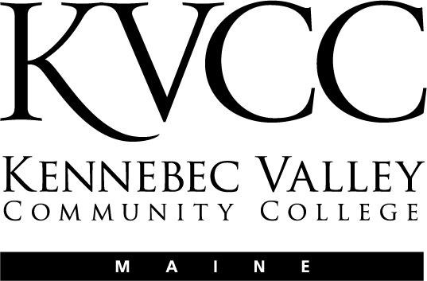
KENNEBEC VALLEY COMMUNITY COLLEGE
FAIRFIELD, MAINE

Social Sciences Department
Approval Date: 5/20/15
Semester: Fall 2016

COURSE NUMBER: | MHT104 | CREDIT HOURS: | 3
COURSE TITLE: | Community Mental Health | CLOCK HOURS: | 45
PREREQUISITES: | None
CO-REQUISITES: | None

INSTRUCTOR | VOICE MAIL | OFFICE | E-MAIL ADDRESS
TBA | TBA | TBA | TBA
OFFICE HOURS: | TBA

TEXTS:
No Textbook

OTHER MATERIALS:
N/A

COURSE DESCRIPTION:
This course is designed to focus on the history and systems specific to our current mental health system and the potential plan for our future delivery systems. The community’s role in impacting the mental health system will be examined.
COURSE OBJECTIVES:
Upon successful completion of this course, the student should be able to:

- Describe the theory and historical foundations of the community mental health system.
- Describe the potential relevance of the community as a process and/or method for addressing major mental health social problems.
- Apply the existing empirical knowledge base, including effective modes of community based intervention, to impact change in his or her community based mental health delivery system.
- Relate practical field experience to community mental health systems.
- Apply critical thinking skills to the issues of community mental health.
- Demonstrate proficiency in civic engagement**.

COURSE CONTENT:
Lesson 1: Foundations of Community Mental Health and Illness
Lesson 2: Fundamentals of Mental Health
Lesson 3: Culture and Mental Illness
Lesson 4: Boundary and Ethical Issues in Mental Health Practice
Lesson 5: The Health Care System
Lesson 6: Children, Adolescents, and Mental Health
Lesson 7: Early and Middle Adulthood and Mental Health
Lesson 8: Older Adults and Mental Health
Lesson 9: Community mental Health Problems: Environment
Lesson 10: Community Mental Health Problems: Substance Abuse
Lesson 11: Community mental Health Problems: Violence
Lesson 12: Community Mental Health Problems: Violence Across the Lifespan
Lesson 13: Prevention and Health Promotion in Community Mental Health
Lesson 14: A Vision for the Future
Lesson 15: Wrap Up

COURSE ACTIVITIES:
For each week in this class you will be assigned specific activities. These activities may include reading in the textbook, reading outside material, participation in discussions, quizzes on the text content, and reflection quizzes.

Lesson Plans

The entire course is divided into “Lessons” that cover specific topics and learning objectives in the class. The Lessons are listed in the Course Outline above. Each Lesson introduces you to specific subject matter and asks you to engage in a number of activities. These may include reading, exploring the web, researching, participating in online discussions, quizzes (multiple choice, short answer, and essay questions), and assignments (written work submitted as an attached document in a “drop box”)

Each Lesson consists of:

- A Lesson Plan that outlines the content and provides detailed instructions as to any assignments
- Direct links to any Discussions, Assignments, or Quizzes that go along with that Lesson.

All the Lessons are located in the “Lessons” folder. Click on the Lessons link in the course Menu.

Online Discussions

Online discussions form the backbone of an online class. It is very important for you to participate actively and fully in these discussions. These discussions will be graded and will be available for a specified amount of time (Monday morning until Sunday night on a given week in the course). You are required to participate in these discussions following the instructions that will be provided to you in the online Lessons.

Grading of the online discussions will be done in accordance to this grading rubric:

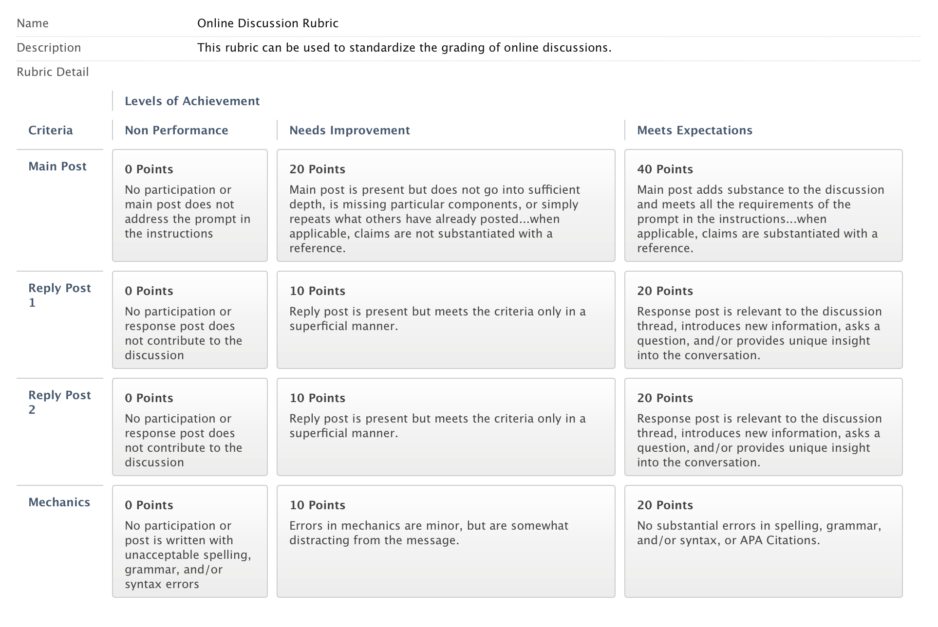

You are, of course, encouraged to post many times through the week. You are also encourages to post EARLY in the week so that you can benefit from others’ responses to your post and so that others may benefit from your responses).

Please review the online document titled “Course Expectations and Policies”

Lesson Quizzes

Within the Lesson Plans you will be provided with a lists of ALL the questions included in the Lesson Quiz and/or directions related to the Lesson Assignment. You should prepare your answers and/or assignments ahead of time and then enter these answers into the appropriate online quiz or drop box.

Quizzes/assignments must be completed by the end of the week in which they are assigned. You may be able to work ahead on some of these as well.

Extensions on the due dates for quizzes/assignments may be allowed with sufficient reason; however, I reserve the judgment to not grant an extension. If you anticipate needing extra time it is best to get in touch with me PRIOR to the due date.

Special Assignments

The following assignments are those that have been incorporated into this class to not only teach you course content, but to also enable you to demonstrate learning associated with the KVCC General Education Outcomes. (See the section on General Education Outcomes at the beginning of this syllabus)

- Service-Learning Project

It is critical that you review the information I have provided for each of these assignments in the course website. While the assignments are not particularly complicated, they are certainly complex, requiring planning and time management to complete them by their due dates.
GRADING:
Grading for the course will be accomplished in the following manner: (This section can be edited)

  - Online Discussions / Attendance 40 %
  - Lesson Quizzes 35 %
  - Service-Learning Project 25 %
GRADING SCALE:

Letter Grades---Based on a final grade scale of 0-100, the following letter grades will be assigned:

  - A
  - A-
  - B+
  - B
  - B-
  - C+
  - C
Below 73 F

Please note that I will not be giving grades below a C. The rationale to this is that students who do not master more than 72% of the material in this class are not prepared to meet the expectations of future classes or programs that require this course. It simply means that you have not learned enough material to really say that you have “passed” the class.
ATTENDANCE POLICY:
Please review the online document titled “Course Expectations and Policies”

OTHER COURSE REQUIREMENTS:
The MHRT/C is a competency-based certification. The following competencies associated with this course have been deemed by the Maine Department of Mental Health Services as necessary to work in the field.

http://muskie.usm.maine.edu/cfl/MHRT/2008%20Guidelines.pdf

- Understands family theory, developmental theory, human development across the life span, counseling theories, and crisis theory
- Knowledgeable about collaborative planning with people with psychiatric disabilities including the following: goal setting, skill assessment and training, and linking with supports in the community
- Understands Maine’s laws regarding mental health recipients’ rights
- Knowledge of the Americans with Disabilities Act (ADA)
- Understands benefit and entitlement programs
- Knowledgeable about etiology, progression, and treatment of major disabling conditions
- Understands interaction of co-occurring medical issues
- Understands role of medication in symptom management
- Understands basic social services and entitlements
- Knowledge of community provider system
- Aware of the need to act as a contributing member of an interdisciplinary team
- Knowledge of confidentiality
- Interacts effectively with community members and other professionals

These outcomes are assessed utilizing a specific set of assignments standardized within the context of the course.
OTHER INFORMATION:
N/A

STUDENTS WITH DISABILITIES (2014)

In accordance with state and federal law, this College is committed to assisting qualified students with disabilities achieve their educational goals.

Students with Disabilities (2016/2017)

Kennebec Valley Community College welcomes students with disabilities, and in accordance with state and federal laws, KVCC is committed to assisting students with disabilities to achieve their educational goals.

In order to receive reasonable accommodations for this course:

• Students must contact the Director of Learning Commons at 453.5084 or cjohnson2@kvcc.me.edu
• Students must provide current, appropriate documentation of their disability
• Students must make a timely request for accommodation to the Director of Learning Commons
• Accommodations will not be provided until the faculty member receives a letter requesting accommodations. This letter is created with the director of learning commons and is supported by the documentation of stated disability
• Requests for accommodation(s) must be renewed each semester for each course

To begin this process, please contact Christy Johnson, Director of Learning Commons at cjohnson2@kvcc.me.edu or 207.453.5084

NOTICE OF NON-DISCRIMINATION (2014):

Kennebec Valley Community College does not discriminate on the basis of disability in the admission to, access to, or operation of its programs, services or activities. Students requesting classroom accommodation should be forwarded to the Dean of Students, Enrollment Service Center, Frye Building, phone: 453-5019 or the Director of the Learning Commons, Lunder Library, phone: 453-5084

Complaints about College decisions related to disability accommodations or discrimination must be forwarded to Affirmative Action Officer and ADA Compliance Officer, Dean of Academic Affairs, Enrollment Services Center, 92 Western Avenue, Fairfield, ME 04937, phone: 453-5822.

