
KENNEBEC VALLEY COMMUNITY COLLEGE
FAIRFIELD, MAINE

Social Sciences Department
Approval Date: 5/20/15
Semester: Fall 16

COURSE NUMBER: | MHT218 | CREDIT HOURS: | 3
COURSE TITLE: | Substance Abuse Counseling for Special Populations | CLOCK HOURS: | 45
PREREQUISITES: | None
CO-REQUISITES: | None

INSTRUCTOR | VOICE MAIL | OFFICE | E-MAIL ADDRESS
David Doreau | See Course | Information in | Blackboard
OFFICE HOURS: | TBA

TEXTS:
Heilig, M. (2015). The Thirteenth Step: Addiction in the Age of Brain Science. Columbia University Press, New York.

OTHER MATERIALS:
See online content

COURSE DESCRIPTION:
This course will examine current literature on substance abuse, paying particular attention to its impact on special populations. High risk populations will be discussed, as well as areas of need of specific populations. Students will read the required textbooks and participate in class discussions designed to help develop and enhance their learning.
LEARNING OUTCOMES:
Upon successful completion of this course, the student should be able to:

- Understanding of theoretical and methodological approaches for examination of the substance use, abuse, and treatment.
- Provide historical context for the development of the field of substance abuse.
- Become familiar with the language of addiction treatment and of the scientific method, research methodology, and statistical analysis
- Review the scientific method as it applies to the social science of substance abuse
- Develop an appreciation for understand social and psychiatric problems using language common to the study of substance abuse assessment and treatment
- Demonstrate proficiency in critical thinking (ELO)*.

* Essential Learning Outcomes demonstrate skills and knowledge related to general education learning outcomes as defined by the college. Specific rubrics within the course are used to assess these outcomes.

COURSE CONTENT:
Lesson 1: Introduction to the Course
Lesson 2: Substance Use Disorders Overview
Lesson 3: Basic Neuropsychology and Genetic Issues
Lesson 4: Psychological, Social, Family, Cultural, and Spiritual Issues
Lesson 5: Change
Lesson 6: Nicotine Use Disorder
Lesson 7: Drunkards, Alcoholics, or Problem Drinkers
Lesson 8: The Opiate Epidemic
Lesson 9: Stimulant Use Disorder
Lesson 10: Cannabis Use Disorder
Lesson 11: Sedative and Hypnotic Use Disorder
Lesson 12: Co-occurring Disorders – Part 1
Lesson 13: Co-occurring Disorders – Part 2
Lesson 14: Screening and Assessment Strategies
Lesson 15: Review and Summation

COURSE ACTIVITIES:
For each week in this class you will be assigned specific activities. These activities may include reading in the textbook, reading outside material, participation in discussions, quizzes on the text content, and reflection quizzes.

Lesson Plans

The entire course is divided into “Lessons” that cover specific topics and learning objectives in the class. The Lessons are listed in the Course Outline above. Each Lesson introduces you to specific subject matter and asks you to engage in a number of activities. These may include reading, exploring the web, researching, participating in online discussions, quizzes (multiple choice, short answer, and essay questions), and assignments (written work submitted as an attached document in a “drop box”)

Each Lesson consists of:

- A Lesson Plan that outlines the content and provides detailed instructions as to any assignments
- Direct links to any Discussions, Assignments, or Quizzes that go along with that Lesson.

All the Lessons are located in the “Lessons” folder. Click on the Lessons link in the course Menu.

Online Discussions

Online discussions form the backbone of an online class. It is very important for you to participate actively and fully in these discussions. These discussions will be graded and will be available for a specified amount of time (Monday morning until Sunday night on a given week in the course). You are required to participate in these discussions following the instructions that will be provided to you in the online Lessons.

Grading of the online discussions will be done in accordance to this grading rubric:

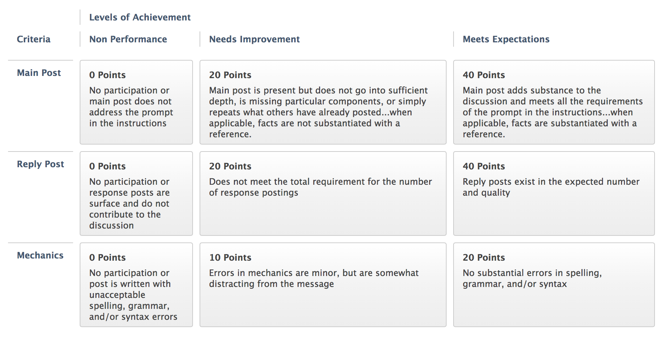

You are, of course, encouraged to post many times through the week. You are also encourages to post EARLY in the week so that you can benefit from others’ responses to your post and so that others may benefit from your responses).

Please review the online document titled “Course Expectations and Policies”

Lesson Quizzes/Assignments

These quizzes will consist of questions related to activities I assign in the class, the content of the discussions, or information you gather from research or from your interview (see below).

Within each Lesson outlined you will be provided with a lists of ALL the questions in the specific quiz. You should prepare your answers ahead of time and then enter these answers into the appropriate online quiz.

Quizzes must be completed by the end of the week in which they are assigned. You may be able to work ahead on some of these quizzes as well.

Extensions on the due dates for quizzes may be allowed with sufficient reason; however, I reserve the judgment to not grant an extension. If you anticipate needing extra time it is best to get in touch with me PRIOR to the due date.

Book Quizzes

There will be four multiple choice quizzes on the textbook.

Critical Thinking Special Assignment

A paper discussing AA/abstinence model vs. Controlled drinking/harm reduction model. More information will be provided online.
GRADING:
Grading for the course will be accomplished in the following manner.

- Graded Discussions 20%
- Lesson Quizzes/Assignments 40%
- Book Quizzes 20%
- Special Assignment 20%
GRADING SCALE:

Letter grades---based on a final grade scale of 0 – 100 the following letter grades will be assigned:

95 – 100 A
90 – 94 A-
87 – 89 B+
83 – 86 B
80 – 82 B-
77 – 79 C+
73 – 76 C
Below 73 F
ATTENDANCE POLICY:
Please review the online document titled “Course Expectations and Policies”

COURSE REQUIREMENTS:
The MHRT/C is a competency-based certification. The following competencies associated with this course have been deemed by the Maine Department of Mental Health Services as necessary to work in the field.

http://muskie.usm.maine.edu/cfl/MHRT/2008%20Guidelines.pdf

- Aware of prevalence and common effects of co-occurring disorders (substance abuse and mental health)
- Aware of screening and assessment strategies for co-occurring disorders (substance abuse and mental health)
- Aware of stages of recovery of persons who have co-occurring disorders
- Knowledgeable about resources to assist in recovery process for persons who experience co-occurring disorders
- Aware of the need to evaluate effectiveness of personal practice
- Understands effective use of supervision

These outcomes are assessed utilizing a specific set of assignments standardized within the context of the course.
OTHER INFORMATION:
N/A

STUDENTS WITH DISABILITIES (2014)

Kennebec Valley Community College welcomes students with disabilities, and in accordance with state and federal laws, KVCC is committed to assisting students with disabilities to achieve their educational goals.

In order to receive reasonable accommodations for this course:

• Students must contact the Director of Learning Commons at 453.5084 or cjohnson2@kvcc.me.edu
• Students must provide current, appropriate documentation of their disability
• Students must make a timely request for accommodation to the Director of Learning Commons
• Accommodations will not be provided until the faculty member receives a letter requesting accommodations. This letter is created with the director of learning commons and is supported by the documentation of stated disability
• Requests for accommodation(s) must be renewed each semester for each course

To begin this process, please contact Christy Johnson, Director of Learning Commons at cjohnson2@kvcc.me.edu or 207.453.5084

NOTICE OF NON-DISCRIMINATION (2014):

Kennebec Valley Community College does not discriminate on the basis of disability in the admission to, access to, or operation of its programs, services or activities. Students requesting classroom accommodation should be forwarded to the Dean of Students, Enrollment Service Center, Frye Building, phone: 453-5019 or the Director of the Learning Commons, Lunder Library, phone: 453-5084

Complaints about College decisions related to disability accommodations or discrimination must be forwarded to Affirmative Action Officer and ADA Compliance Officer, Dean of Academic Affairs, Enrollment Services Center, 92 Western Avenue, Fairfield, ME 04937, phone: 453-5822.

