KVCC Center for Civic Engagement

Mission
The mission of the KVCC Center for Civic Engagement is to educate, inform, excite, and motivate students, faculty, and community partners regarding the personal, education, and social benefits of integrating Service-Learning and Civic Engagement into one’s personal, academic, and social life.

Purpose
The purpose of the KVCC Center for Civic Engagement is to provide sustainable structure within the college to support the civic mission of the college, to engage the local and wider community, to inform our community members regarding the need for civic engagement, and to support continued pursuits of justice and equity in our society.

History
The CCE was established in 2003 as a result of a partnership between KVCC and the Maine Campus Compact. Emily Lance, a VISTA contracted to KVCC through Campus Compact, worked to establish the use of Service-Learning as a teaching methodology across a number of programs.

During this period of time, Dr. Mark Kavanaugh was hired by the College to teach Social Sciences and he quickly became involved in Service-Learning. A proposal was brought to the Administration to establish an official office for the promotion of Service-Learning and Civic Engagement and the Center for Civic Engagement was established.

Since that time, the Center has pursued its mission to advance the cause of Service-Learning and Civic Engagement across the KVCC community.

(See data sheet for academic year, semester, total hours, and total value added since 2003)

Fall 2018 Report

Basic Statistics

Total Hours of Service…………………………………………………………………………………………………….1113

Total Number of Students Involved……………………………………………………………………………………50

Total Number of Community Partners Involved…………………………………………………………………60

Total Value Added Economic Impact to Community………………………………………………..$25,076*

*Economic impact of volunteer service is calculated at a rate of $22.53 for the State of Maine, according to Independent Sector - https://independentsector.org

List of Community Partners

- Alfond Youth Center
- Bagged Meal Program
- Bangor Area Homeless Shelter
- Belfast Maine Soup Kitchen
- Benton Elementary School
- Bikers Against Child Abuse
- Camp Sunshine
- Camp Susan Curtis
- Carry Me: Babywearing Alliance of Maine
- Cedar Mill Farm and Cabins
- Clinton Elementary
- Community Greenhouse Project
- Community Outreach Project Food Drive
- Corp. Cole 5k and Half Marathon
- Country Manor Nursing Home
- Crosspoint Church
- Dempsey Center Dempsey Challenge
- Domestic Violence Project
- Educare
- Fairfield Antique Mall
- Faith Temple Church of God
- Family Violence Project
- Farrington Elementary School
- FMHI
- Gardiner Public Library
- Gateway Community Boosters
- Glenridge Long Term Care
- Handyman Services
- Harmony Cares
- Inch by Inch Preschool
- Inland Hospital
- Intervarsity Christian Fellowship
- Kennebec Valley Humane Society
- KVCC
- KVCC Farm
- KVCC Food Pantry
- KVCC PTA Club
- L&F Transport
- Madison Elementary
- Maine Democratic Party
- Mid Maine Homeless Shelter
- Mount View High School
- New Hope Woman's Shelter
- Perspectives after school
- Phi Theta Kappa
- Pine Tree Academy
- Redington Fairview General Hospital
- Rome Volunteer Fire Department
- Somerset Humane Society
- St. Mark’s Episcopal Church
- Star in the West Masonic Lodge #85
- The Church of Jesus Christ of Latter-Day Saints
- The Maine Health Information Management Organization (MeHIMA)
- Togus VA Hospital
- Troy Central PTO
- Waldo County Action Partners and the Head Start program
- Waterville Homeless Shelter
- Waterville Youth Soccer Association
- Western Maine Center for Children
- Whitefield Elementary School

KVCC Courses that Support Service-Learning

- COM 104 – Introduction to Communication – Total Hours - 10
- MHT 104 – Community Mental Health – Total Hours - 79.5
- MHT 125 – The Changing Workplace – Total Hours - 87
- MHT 220 – Case Management – Total Hours - 80.5
- PTS 211 – Physical Therapy III – Total Hours - 122.25
- SOC 101 – Introduction to Sociology - Total Hours - 733.75

Total Hours Per Course

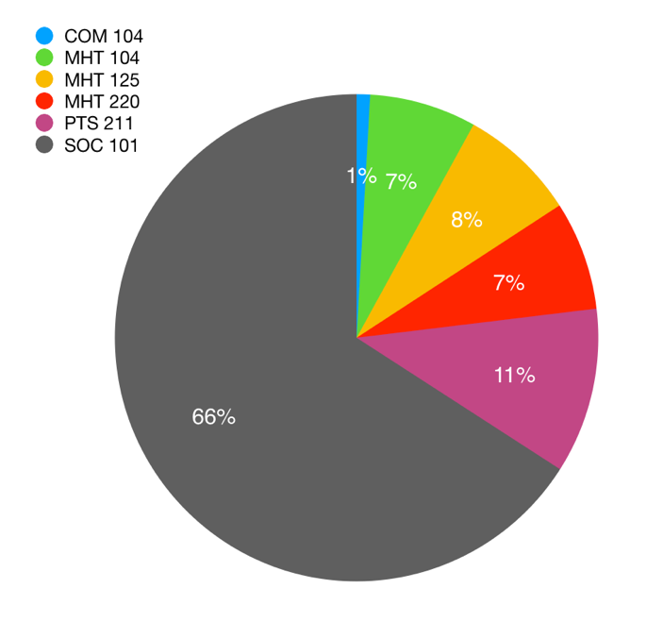

Program Representation Among the Students

The following is a list and statistics of the programs represented by students in this data set.

- Business Marketing and Management
- Early Childhood Education
- General Science
- Liberal Studies
- Mental Health
- Non-Matriculated
- Nursing
- OTA
- Paramedic
- PTA

Total Hours Per Program

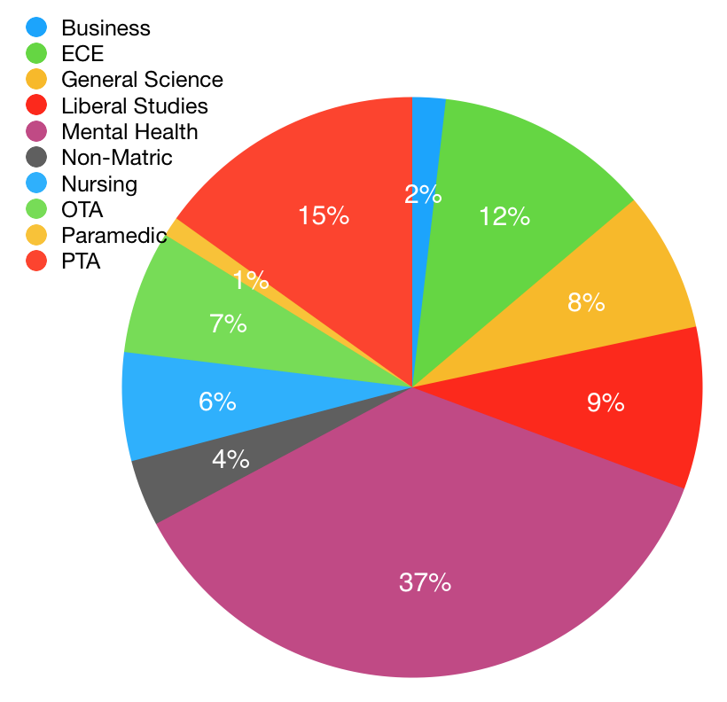
Student Stories

The following is a selection of 50 brief stories that students reported from their experiences in their service projects.

- It was fun! I have changed my mind and am going to further my education on mental health
- I was so amazed at how smart the fourth graders were and how welcoming they were. Every time I entered that classroom, I found out something new about each one of the students!
- Was able to connect with women who are trying to build their life back up.
- I enjoy being in a medical setting lots of times so for me to be back in a hospital, I loved it. It is always nice to see the people care so much that you are helping them feel better. There will always be that one person who isn't that nice, but you have to take a step back and know that they are hurting and that’s how they deal with it.
- I helped may children with their literacy skills, built egos, and created great memories for myself.
- I have also included in my project a PowerPoint to be distributed to First Responder Departments for trainings.

- I really enjoyed connecting with some of the residents in the short time I was there. The staff were also very welcoming, which made me want to continue to volunteer once a month.
- I was able to make direct contact with others and form relationships with those around me.

- Although I didn’t get much contact with those in use of the soup kitchen, those I volunteered with were able to tell me stories of when they were homeless and how the soup kitchen helped them get back on their feet.
- I learned anyone at any time can be homeless
- I was able to volunteer at the shelter and learn more about the connection between mental illness and homelessness
- It was exciting to work within the homeless shelter and with the residents of the shelter, I enjoyed the aspect of doing the hours at the shelter the most
- Every Christmas and even thanksgiving I find a way to help those in need. All through every year I will give money to people on the street as well.
- As a group project for a community outreach, we decided as a community of students at KVCC, to help those that are in our community, our peers, that are experiencing food insecurity.
- It was nice seeing how grateful Landi was that we pulled together some more food for the students at KVCC.
- We were able to donate 281 food items!!
- Our project in itself is exciting because we raised awareness of the issues of hunger in Maine as well as set up a food drive for our school food pantry to help students who should not have to worry about going hungry while getting an education.
- I was happy to learn our campus had a food cupboard! I had no idea, so it was really great to work on the project.
- We got to hand out all the runner’s shirts and cheer on runners
- Cleaning up/preparing a summer camp for under privileged children, so that they could have a fun filled summer.
- Cheered people on as they ran a 5K to support raising awareness for domestic violence
- I have been spreading my love for basketball by teaching others how to work as a team.
- It was fun to do something for the school and be a part of the great things the farm does and provides for students
- We were able to donate our dolls to kiddos who have knee braces or helmets to make them feel less alone
- It was great to know that we were supporting our troops with packages that the may not get otherwise
- I got to see that some of the kids were very interested in what we did. they may decide to choose this path
- It was enriching to be part of such a meaningful event that made a huge impact on the local and statewide community. My part was small, but I learned it takes a lot of small jobs to pull off such a huge event.
- It was a fun event to work as a class. It provided team bonding. It was also neat to learn about how to apply plastic to the greenhouse.
- I appreciated the opportunity to give comfort to children facing medical challenges.
- We met a man, while sitting at a table with coffee and donuts. He spent his life living at the brunt of the foster care system. With the community we shared, I just gave him rides to places he needed to go, and he just wound up hanging out with us a lot. After like a month or two, at one of our members' graduation parties, he came up to two guys who he trusted and told us that he wanted to give his life to Jesus. As a Christian, I am happy because I have understanding that having Jesus in someone's life will impact them for great ways. As an organization, in a humanistic perspective, I think we were successful, many Christians throughout the ages have marred the image of Jesus with weird stories and acting on misinformation. We successfully shared the love of Jesus in a way that he saw as noticeable. We were able to love one person as an organization, in a way which they saw was evidence of Jesus. We were professing to love a God who loves us, and according to John 13:35 (Bible verse) that people will know if we're actually followers of Jesus by the love we have for one another. It was a success on multiple levels
- I loved putting a smile on the residents faces, it was a great feeling of accomplishment

- It felt great to help out someone that is used to doing it all on her own. I enjoyed interacting with people from all different states was interesting.
- I got to learn that truck drivers are wrongly stereotyped.
- I got to meet so many great and new faces and really have an eye opener to be grateful because you never know when something of yours could be gone and not everyone is a bad person just because of where they are in life.
- During the time I spent volunteering this semester our group has been working on expanding our outreach programs to areas of Maine that we have previously been unable to work in.
- I was able to listen to a lady tell her life story who was afraid to because she thought she would be made fun of. She told her story to me and then lit up like a Christmas tree after because I sat there and listened to her and told her that nobody would make fun of her. I felt accomplished
- I get to work in a hospital, and I want to be a nurse!
- Helping the children was rewarding because they were so excited to do a fun project!

- KVCC will hold its first annual Eating Disorder Awareness events in the spring semester of 2019
- Chemistry Day was exciting, and I helped the Colby College Chemistry club with setting up and was the door person.
- I gained valuable practice in working with children in a classroom setting
- I was very excited to do this project because I've always wanted to volunteer at the Humane Society, and this allowed me to. I was able to work with a lot of animals, which was what I wanted, and I even adopted a kitten during the duration of it!
- I love reading and always have throughout my life - it was amazing to watch that light brighten in children! I have participated in this project for several years and will continue to travel back to my home town to participate in this project for years to come, I am sure!!
- I learned that I might want to work with younger children, rather than kids who are a little older. These children were so caring and lovable, yet so aware of other emotions.
- I get to audition actors next weekend! They'll be reading parts of my script, so it'll be pretty rad to see the words manifest outside the page.
- I've learned a lot from the older generations due to my service
- This project was challenging to start due to finding an organization of interest that had available hours that coincided with my availability. I started out not putting much into the project, due to thinking that I was not making a lot of difference. I ended up doing more to help some of the people who came to receive the bagged dinners, by listening, researching agencies that could help them with some of their barriers, and educating them as well as peers in the group. I became more culturally aware of the diversity in our community, and the stigmas, prejudices, and biases attached to our diversified population. I grew as a person and developed a stronger sense of self in the process. I plan to continue promoting cultural diversity in my community and am currently trying to set up a group to help answer questions and provide information about community resources to help those affected by different issues
- I was excited to go back to the preschool my brother attended and have such an awesome experience! The kids loved me and enjoyed having a guest at the school. I had a great time learning and taking notes for my paper.
- I learned a lot about the kind of leader that I want to be.
- The most exciting and nerve-wracking experience was attending the AHIMA Advocacy Summit in Washington, D.C. twice in March of 2017 and 2018 where we had the chance to speak to our state representatives about issues important to HIM professionals.

Spring 2019 Report

Introduction

The following is a summary of the data collected by the KVCC Center for Civic Engagement regarding civic engagement, community service, and service-learning activities for the Fall 2018 semester.

This should not be considered a completely accurate account of the projects that have occurred during this time because we are still establishing the culture and expectations of reporting service through the survey managed by the Director of the CCE.

Basic Statistics

Total Hours of Service 1757

Total Number of Students Involved 98

Total Number of Community Partners Involved 70

Total Value Added Economic Impact to Community $39,585

*Economic impact of volunteer service is calculated at a rate of $22.53 for the State of Maine, according to Independent Sector - https://independentsector.org

List of Community Partners

None of this would be possible without the connections we have with agencies and organizations in the community. This semester we partnered with 70 distinct organizations (including a number of KVCC groups!)

- Albion Elementary School
- Albion Public Library
- Atwood-Williams PTA
- Bridges Spectrum Generations
- Brooks Park Boosters
- Canaan Library
- Cedar Ridge Nursing Home
- Clinton Elementary School
- Decal Gymnastics
- Down East Recovery Group
- East Pittston United Methodist Church
- Educare
- Emmaus Homeless Shelter
- Family Violence Project
- EDCAP
- Fresh Start
- Gabriel Rowe
- Garry Owens Shelter
- Gateway Community Boosters
- Gold Ribbon Group at Messalonskee
- Green Maple Farms
- Gymnastics Camp with Central Church and Mainely Gymnastics
- Habitat for Humanity
- High School Host Family
- His Servants Ministries
- Home Supports for Living Innovations
- House of Hope
- KVCAP
- KVCC
- KVCC Farm Learning Center
- Kennebec Valley Humane Society
- Lawrence Public Library
- LifeChurch
- Literacy Volunteers of Farmington
- Madison Softball Youth Pitching Clinics
- Maine General
- Mainely Gymnastics
- Mancehster Equestrian Center
- Messalonskee Recreation al Baseketball
- Mid Maine Homeless Shelter
- Miles Lane Elementary School
- Mount St Joseph Rehabilitation Center
- Oakland Recreation Department
- P.A.W.S. Animal Shelter
- PALS Cat Shelter
- Pittsfield Public Library
- Pittsfield Recreation Department
- Pruvit Independent Business
- ReVision Energy
- Sacred Heart Soup Kitchen
- Salvation Army
- Skowhegan Boys Basketball Boosters
- Skowhegan Community Center
- Somerset Humane Society
- Stillwater Healthcare
- Strong United Methodist Church
- Tall Pines
- Temple Academy
- The Least of These
- The Point Ministries
- The Warming Hut
- Togus VA
- Trek Across Maine – Yellow Brick Road Concert
- TRiO Program
- United Methodist Economic Ministry
- Vassalboro Food Bank
- Waterville Area Humane Society
- Waterville Fire Department
- Waterville Opera House
- Wilson Stable

KVCC Courses that Support Service-Learning

The following is a breakdown of the number of service hours generated by students within the courses that currently support Service-Learning.

- BUS 218 – The Entrepreneur’s Guide to Small Business Management – Total Hours - 76
- MHT 104 – Community Mental Health – Total Hours - 372
- MHT 125 – The Changing Workplace – Total Hours – 130
- MHT 214 – Incest, Sexual Abuse, and Trauma – Total Hours - 10
- MHT 220 – Case Management – Total Hours - 239
- SOC 101 – Introduction to Sociology - Total Hours - 993

Total Hours Per Course

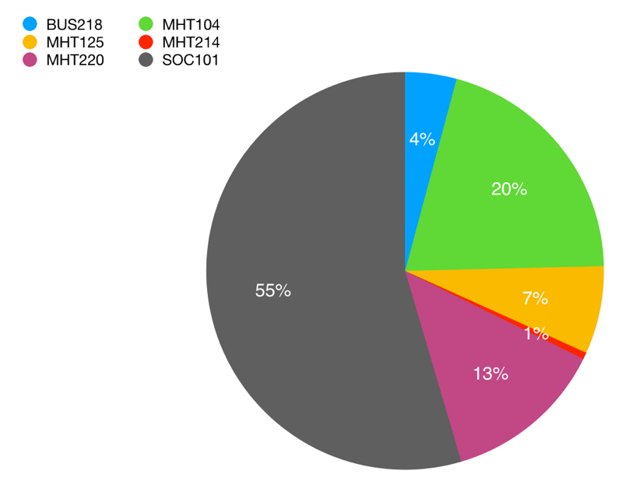

Program Representation Among the Students

The following is a list and statistics of the programs represented by students in this data set.

- Business Marketing and Management – Total Hours - 46
- Culinary Arts – Total Hours – 108
- Early Childhood Education – Total Hours - 61
- Electrical Technology – Total Hours – 3
- General Science – Total Hours – 266
- Liberal Studies – Total Hours – 114
- Mental Health – Total Hours – 623
- Mental Health Certificate – Total Hours – 68
- Non-Matriculated – Total Hours – 114
- Nursing – Total Hours – 156
- Nutritional Dietician – Total Hours – 104
- OTA – Total Hours – 31
- Psychology – Total Hours – 8
- Respiratory Therapy – Total Hours – 10
- Sustainable Agriculture – Total Hours – 30

Total Hours Per Program

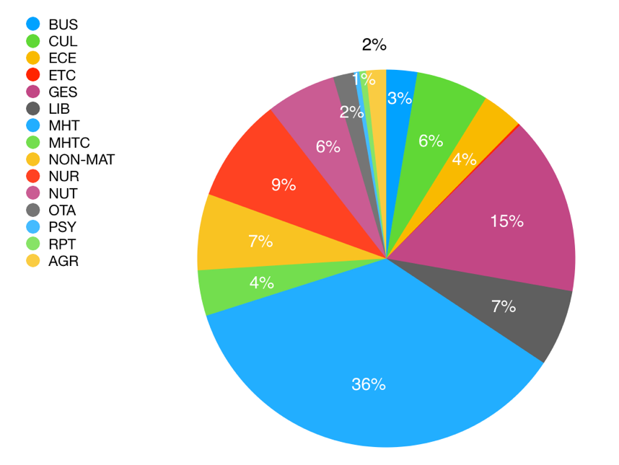

Student Stories

The following is a selection of 50 brief stories that students reported from their experiences in their service projects.

- We were able to put on the dinner with no cost of us, yielding 100% profit!
- I wrote my paper and am so happy that I got to spend this time with these amazing people.
- This is a great opportunity to find out who you really are and what you want to do with your life :D
- I was able to help the four-year-old successfully pronounce six letters! I was able to help the high school student raise her math and history grades to average instead of below average!
- I will be a member for the next 3 seasons. I support all booster programs. I am also baseball secretary. I work full time, take classes and volunteer. My husband is also a volunteer and huge supporter of basketball at SAHS. He coaches. It always great to see kids benefit from the fundraising we do.
- The best Elton John tribute band was the acc for the concert.
- I was able to raise 1000.00 for the iPod initiative! It gave us the money not only to purchase the needed number of iPods, but also headsets and iTunes cards for the patients. Initial goal was only 500.00.
- I got to separate work from my passion of helping kids and being involved in the sport of gymnastics. I was able to have fun while volunteering my time and knowledge.
- I was able to work with kids of all ages to give them all an experience with the amazing sport of gymnastics.
- I enjoyed making the dogs and cats feel loved.
- I was nominated as one of the best helpers there and they already want me to help again next year.
- I learned that a lot of my old teachers from grade school through high school compete in Pickle Ball tournaments.
- I was able to use fun games that were easy to play, but also helped teach the lesson
- I got to help improve the chances of animals getting adopted.
- I painted the entire backdrop that represented rural Kansas in the Wizard of Oz.
- it was focused around working with Jr Highs, it was amazing to get to see them learn about God in the ways we got to teach them.
- The community comes together and donates items to then sell then build homes for families. the most exciting part was to see people’s faces when they came in to see the decent priced items.
- Making connections with people that are often lost in the shuffle of life
- I was able to make meaningful connections at Educare with both the teachers and the children!
- Caring and giving the animals positive attention is good for the mind, body and soul of both animal and human.
- Ted Greene with Greene Maple Farm has connection with the Warming hut, and other community members who assist people in need. Through his connections I was able to assist in gathering needed items and resources. Sebago is a small town, and there are no homeless shelters per say, so lots of people I met and spoke with couch-surfed, but they had no place to really call their own. I was also able to help with families in the surrounding communities, who lost their home to a fire.
- I met a lot of really wonderful people, both who were working at the shelter and who were staying at the shelter.
- I was able to speak with a person residing at the homeless and we talked about their story of how they became homeless. It was very humbling.
- I found it very eye opening. Sebago is a small town, and we do not have any shelters per say, however the warming hut is a place people seek assistance, I was able to meet people that attend here regularly whom, through Ted Greene and Greene Maple farm were very needy.
- It felt amazing to raise as much as we did for such a great cause. Awareness is so big, and this is a great start.
- Donated $1132.17 in cash and gift cards, cleaning supplies, personal hygiene items, kitchen equipment, books and ideas of groups to contact for food sustainability.
- I think the most exciting part for me was being able to speak at the state house regarding LD-1171.
- Our group did an incredible job of maximizing each member's individual strengths while minimizing and working around what would have otherwise been barriers. We took the time to really identify how each member could best contribute, and ways that one person's strengths more than compensated for needs in other areas.
- We are helping with getting information out that there are people in need, and we are trying to help them and let them know they don't have to go without.
- This lady who was homeless has received a whole family at the church she is going to and no longer has to suffer alone, it is very beautiful and seems as though maybe in people would accept going to church more, they would be in a better place.
- I really feel that there was one boy in there that I could see a lot of myself in. He shared with me a little of his struggles with mental health and I let him know that things do get better in time, and after we talked, he seemed to be impacted in a positive way. I worked in the school with children to get an idea on how I would feel working with them in my career, and they (along with the teacher) felt that I was really strong in terms of communicating and listening to them.
- We got to stay for the concert of Yellow Brick Road Band and the performance was amazing!
- We created a personal survey that individuals from our school took and we got a lot of feedback on this topic if they have or know someone who has experienced these topics.
- I made people smile!
- We met our goal of $1000 in money raised plus spread the word about the center and recovery!
- Going to Health and Human Services committee at state house, to tell story and testify about the negative impacts of Fedcap.
- I got to wear a Kentucky derby hat!
- I learned there are some really great story endings for clients who receive assistance and help from the homeless shelter.
- We served a nice meal for 50-60 people at the shelter.
- The yard sale raised a little over $600! The money raised will assist in purchasing items people need to set up a new home after being homeless.
- I thought I wanted to be a Dental Hygienist for the longest time! After working with young kids, I've decided Id like to be a teacher!
- I've learned how to be a better leader since I've become vice president in the group.
- I thoroughly enjoyed helping these young athletes and seeing their progression over the clinics.
- I love working with young children! After high school I want to go on to college to get a degree in Early Education and then go on to become a Kindergarten teacher. I believe the time I spent volunteering helped me get one step closer to this goal.
- The girls that I helped are doing a research project of patients that are part of the mental health institution at the VA. They are trying to find an association between patients, whether it be sleep level and dementia, or other things. This is interesting to me because I want to pursue a degree in psychology and will probably have to do a research project of such.
- I really enjoyed my time at the humane society and will be returning thanks to this project!
- The humane society loved what I was doing and the impact on a dog that has extreme anxiety. She is much calmer now and is more likely to relax. Now, they are trying to get the reading program going again. The feeling of helping is so amazing.
- I was able to deepen my knowledge of cultural differences within my community and why that makes us stronger.
- It is a great feeling to help others that need help.
- I found out how much I really want to own an animal shelter and give them the great care they deserve.
- The library is planning to have an expansion, and I am allowed to make suggestions for how I think the library should be.
- Helped to make cinnamon buns and bird feeders.
- Because the students I hosted were from Japan I got the opportunity to have a traditional meal made by them and also get to know them and things about their culture.
- I got to play music and dance with some really cool kids!
- I had such a blast with the children there doing arts and crafts! I was actually sad when my hours were done.
- I got to engage with some pretty amazing kids and get to bring out their personalities a little more through basketball.

Projects and Activities

The following section outlines special projects that were completed during the semester. Some of these were completed in the context of Service-Learning while others were simply student and staff initiatives.

MAYSA BLUE ANGELS TRAVEL SOFTBALL SPAGHETTI SUPPER

Andreya Dubois, a student at KVCC, is supporting a project in her community.

On March 15, 2019, from 6-8 PM, at the United Methodist Church on Church St. in Clinton ME.
All proceeds ($7.00 per person, under 5 eat for free) will go toward tournament fees for the 2019 season!

There will be a 50/50 raffle at 7:00 PM!
Cake and Pie Auction at 7:10 PM!

A great time to have great food for a great cause!

MUSIC FOR THE ELDERLY

Two students in Mark Kavanaugh’s SOC 101: Introduction to Sociology course developed a program to raise funds to purchase iPod (Shuffle) music players to be used with persons with Alzheimer’s and Dementia at Cedar Ridge Long Term Care in Skowhegan.

Rebecca Jipson and Jessica Small envisioned the program following a lecture on the topic in the class. Rebecca was key in contacting local companies for monetary donations. She found that many of the persons she encountered had their own story of loved ones who have suffered from these conditions. She found no reluctance to donate on the part of the companies, although each of the participating organization has chosen to remain anonymous and requested no documentation at all.

Rebecca raised a total of $1000

We purchased 15 iPod Shuffles, 40 disposable headphones, chargers, and $200 worth of iTunes Gift Cards.

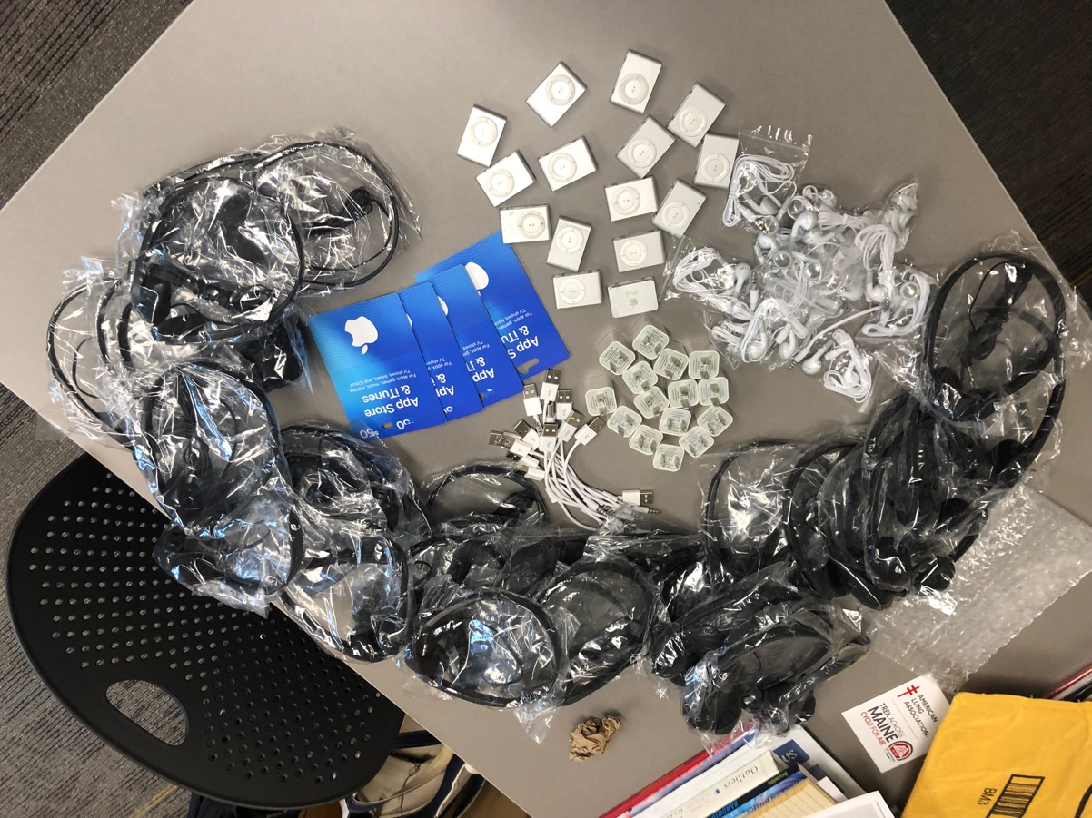

PROMOTIONAL VIDEO FOR INFANT MENTAL HEALTH

The Maine Association for Infant Mental Health, which is located at the Waterville EDUCARE, contacted the Center for Civic Engagement regarding the use of volunteers to meet their objectives. During the meeting it came to light that they were in the process of planning for a Promotional Video regarding parents’ role in developing resilience in young children.

The Center for Civic Engagement reached out to the campus community and to Jessica Powell (Early Childhood Education) to recruit students for this project.

The following people were involved in this project:

- Mason Peterson
- Elissa LaVoie
- Brittany Dixon
- Caitlin Dodge
- Mark Kavanaugh
- Jessica Powel

The group met several times over the course of two months and with the leadership of Mason Peterson, a public service announcement 60 second video was created and delivered to the Commission ahead of schedule.

https://youtu.be/FCU_nNYLPP0


“A PARABLE OF HIM” – A film by Mason Peterson

Beginning in the Fall of 2018, Mason Peterson was a student in Mark Kavanaugh’s SOC 101 – Introduction to Sociology class. Mason decided to produce and promote a film. Mason worked with his instructors in Sociology and his Honors Program to develop his ideas. Eventually, he focused the work on the topic of “Toxic Masculinity” and began pre-production.

Over the course of the Fall 18 and Spring 19 semesters, Mason completed filming, editing, and promoting the film. Working with KVCC, Mason screened the movie in the Lecture Hall at the Sustainable Agriculture Building on the Alfond Campus of KVCC.

The screening was very well attended, and conversation about the nature of the film and the nature and issue of toxic masculinity was rich and engaging.

Mason has submitted the film to a number of events and will be screening “A Parable of Him” at Waterville’s Railroad Square Theater and in Portland, ME.

Summer 2019 Report

Introduction

The following is a summary of the data collected by the KVCC Center for Civic Engagement regarding civic engagement, community service, and service-learning activities for the semester.

This should not be considered a completely accurate account of the projects that have occurred during this time because we are still establishing the culture and expectations of reporting service through the survey managed by the Director of the CCE.

Basic Statistics

Total Hours of Service 199

Total Number of Students Involved 14

Total Number of Community Partners Involved 11

Total Value Added Economic Impact to Community $3,484

*Economic impact of volunteer service is calculated at a rate of $22.53 for the State of Maine, according to Independent Sector - https://independentsector.org

List of Community Partners

None of this would be possible without the connections we have with agencies and organizations in the community. This semester we partnered with 11 distinct organizations (including a number of KVCC groups!)

- American Red Cross
- GSME
- Hope Haven Gospel Mission
- Lazy Acres 2
- New Beginning Church of God
- Oak Fest Committee
- Pathways of Maine
- Sacred Hearts Soup Kitchen
- Tiger Food Pantry
- Waterville Human Society
- Wild Life Care Center

KVCC Courses that Support Service-Learning

The following is a breakdown of the number of service hours generated by students within the courses that currently support Service-Learning.

- MHT 104 – Community Mental Health – Total Hours – 40.5
- SOC 101 – Introduction to Sociology - Total Hours – 148

Total Hours Per Course

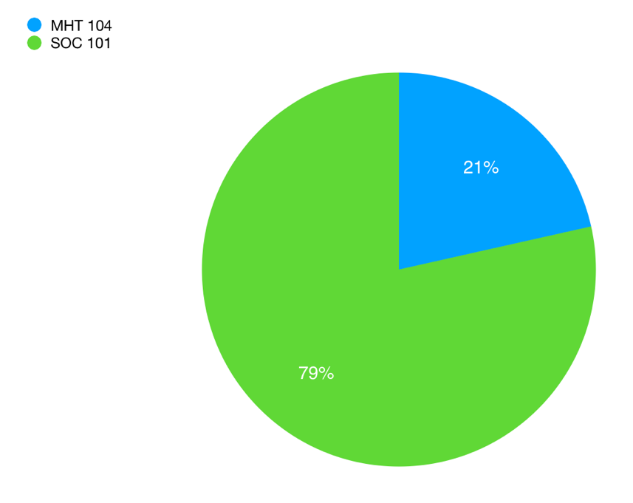
Program Representation Among the Students

The following is a list and statistics of the programs represented by students in this data set.

- Early Childhood Education – Total Hours – 58.5
- General Science – Total Hours – 6
- General Studies – Total Hours - 32
- Medical Biology (UNE) – Total Hours – 10
- Mental Health – Total Hours – 30.5
- Non-Matriculated – Total Hours – 39
- Nursing – Total Hours – 23

Total Hours Per Program

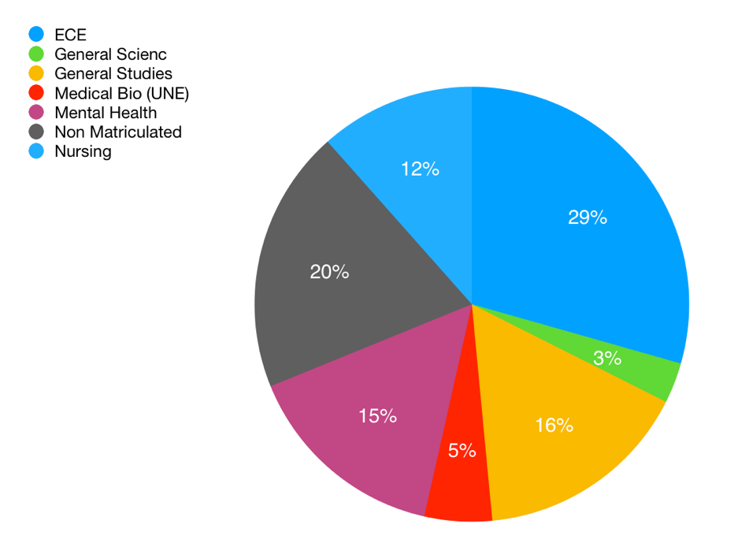

Projects and Activities

The following section outlines special projects that were completed during the semester. Some of these were completed in the context of Service-Learning while others were simply student and staff initiatives.

2019 Concert for the Trek Across Maine

The band Yellow Brick Road performed at the Moody Chapel to raise awareness and funds for the KVCC Chain Lynx cycling team.

The band performed as a trio (piano, bass, and drums) rather than the traditional five members of the band. The audience was treated to a full concert experience and a set of songs as they were first recorded when Elton performed in a trio!



www.tributetoeltonjohn.com

$400 was raised and was distributed to the fund-raising accounts of each rider!

2019 Trek Across Maine

For several years KVCC has fielded a team of cyclists for the Trek Across Maine. This year we did it again! The big news this year was after 34 years of riding the same roads across Maine, the Trek decided to change the route!
This year’s Trek started on the coast at Brunswick Landing. Our first day brought us to the campus of Bates College. A very touch second day brought us to the campus of Colby College and the third day was a very nice, essentially downhill, trip to Bath and then back up to Brunswick Landing!

Commemorating the 50th Anniversary of KVCC, the team sported custom shirts.

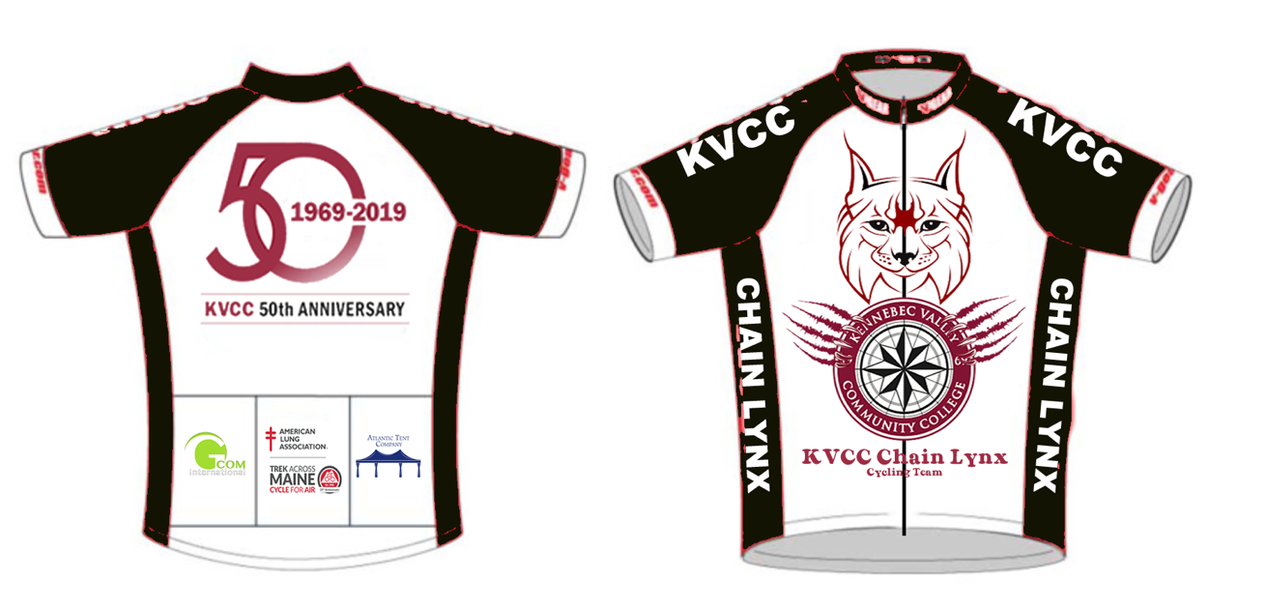

This Year’s Team

This year’s team consisted of the following:

- Mark Kavanaugh (Team Captain)
- Andrew Bourassa
- Alicia Collins
- Ron Douglas
- Jordan Godin
- James Ross

Total Funds Raised - $4006.00



